<https://github.com/roxanazachman01/FLCD>

**Documentation:**

Finished yacc:

%{

#include <stdio.h>

#include <stdlib.h>

#include <string.h>

#define YYDEBUG 1

int yylex();

void yyerror();

int indexes[5000],n=0;

void add_index(int index){

indexes[n]=index;

n++;

}

void print_indexes(){

for(int i=0;i<n;i++)

printf("%d ",indexes[i]);

}

%}

%token CHAR STRING INT IF ELSE READ WRITE WHILE BEGINN END

%token ROP RCP SOB SCB COB CCB COLON

%token PLUS MINUS MULTIPLY DIV LE LT GE GT NE EQ ASSIGN MOD

%token IDENTIFIER

%token CONSTNR

%token CONSTCHAR

%token CONSTSTRING

%%

program: COB decllist cmpdstmt CCB

;

decllist: declaration decllistlala

;

decllistlala: decllist

|

;

declaration: type IDENTIFIER COLON

;

type: type1 arraydecl

;

type1: INT

| CHAR

| STRING

;

arraydecl: CONSTNR SCB

|

;

cmpdstmt: BEGINN stmtlist END

;

stmtlist: stmt stmtlistlala

;

stmtlistlala: stmtlist

|

;

stmt: simplstmt COLON

| structstmt

;

simplstmt: assignstmt

| iostmt

;

assignstmt: IDENTIFIER assignstmtlala ASSIGN expression

;

assignstmtlala: SOB assignstmtlala2 SCB

|

;

assignstmtlala2: CONSTNR

| IDENTIFIER

;

expression: term expression1

;

expression1: PLUS expression1

| MINUS expression1

| expression

|

;

term: factor term1

;

term1: MULTIPLY term1

| MOD term1

| DIV term1

|

;

factor: ROP expression RCP

| IDENTIFIER assignstmtlala

| CONSTNR

;

iostmt: READ ROP IDENTIFIER assignstmtlala RCP

| WRITE ROP writeitem RCP

;

writeitem: lalaitem

| IDENTIFIER assignstmtlala

;

lalaitem: CONSTNR

| CONSTCHAR

| CONSTSTRING

;

structstmt: ifstmt

| whilestmt

;

ifstmt: IF ROP condition RCP COB stmtlist CCB elsestmt

;

elsestmt: ELSE COB stmtlist CCB

|

;

whilestmt: WHILE ROP condition RCP COB stmtlist CCB

;

condition: expression relation expression

;

relation: LT

| LE

| GE

| GT

| EQ

| NE

;

%%

void yyerror(char *s)

{

printf("%s\n", s);

}

extern FILE *yyin;

int main(int argc, char **argv)

{

if(argc>1) yyin = fopen(argv[1], "r");

if((argc>2)&&(!strcmp(argv[2],"-d"))) yydebug = 1;

if(!yyparse()) {

fprintf(stderr,"Parsed with success.\n");

print_indexes();

}

}

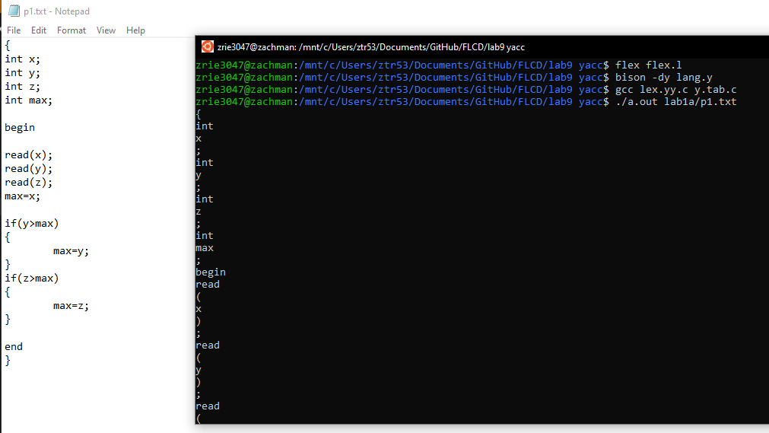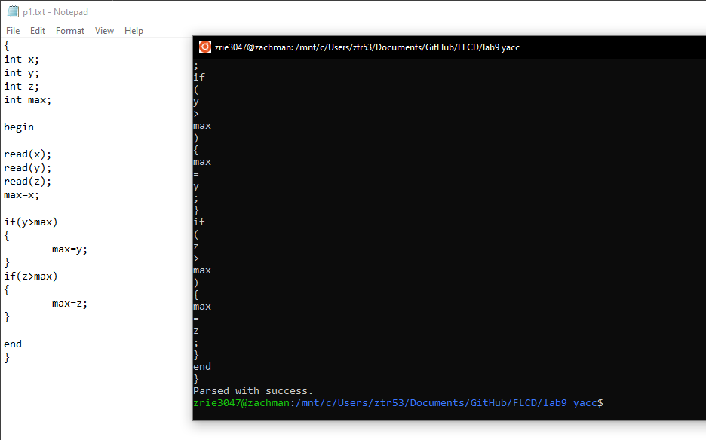

Errors:

